

**DEPARTMENT OF COMPUTER SCIENCE AND DESIGN**

**ACADEMIC YEAR 2024-2025 ODD SEMESTER**



**CD23332**

**LAB MANUAL**

**SECOND YEAR**

**THIRD SEMESTER**

**2024- 2025**

**ODD SEMESTER**

|  |  |  |
| --- | --- | --- |
| **List of Experiments** | | |
| 1 | Design to teach mathematics to the children of 4-5 years age in school in Rural sector | |
| 2 | Design to help people to sell their handmade products in metro cities | |
| 3 | Design a social media website and chat | |
| 4 | Design a publication that support different languages | |
| 5 | Design a publication that tells comic stories | |
| 6 | Design an advertisement for mobile company | |
| 7 | Design an advertisement for any political party with images | |
| 8 | Design an advertisement for electronic products | |
| 9 | Design an advertisement for food products | |
| 10 | Design an interactive website for new institution | |
| 11 | Design a blog that publish educational post | |
| 12 | Design an interactive website for hospital management system | |
| 13 | Design an interactive website for food selling app | |
| **Requirements** | | |
| Hardware | | Intel i3 or AMD processor with 64-bit support;2 GHz or faster processor with SSE 4. or later- 8 GB RAM -Windows 10 64-it (version 1909)or later - 1.5 GB of GPU memory -4 GB of available hard-disk space |
| Software | | Figma, Adobe Photoshop, HTML and CSS |
| Operating System | | Windows |

**LAB PLAN**

**CD23332-DESIGN PROCESSES AND PERSPECTIVES LAB**

|  |  |  |
| --- | --- | --- |
| **Exercise no.** | **Exercise Name** | **Required**  **Hours** |
| 1 | Design to teach mathematics to the children of 4-5 years age in school in Rural sector | 3 |
| 2 | Design to help people to sell their handmade products in metro cities | 6 |
| 3 | Design a social media website and chat | 3 |
| 4 | Design a publication that support different languages | 3 |
| 5 | Design a publication that tells comic stories | 3 |
| 6 | Design an advertisement for mobile company | 3 |
| 7 | Design an advertisement for any political party with images | 9 |
| 8 | Design an advertisement for electronic products | 6 |
| 9 | Design an advertisement for food products | 6 |
| 10 | Design an interactive website for new institution | 6 |
| 11 | Design a blog that publish educational post | 6 |
| 12 | Design an interactive website for hospital management system. | 3 |
| 13 | Design an interactive website for food selling app. | 3 |

**Course Outcomes (COs)**

**Course Name: Design Processes and Perspectives Course Code: CD19341**

|  |  |
| --- | --- |
| Outcome 1 | Understand the various graphic design thinking process and phases |
| Outcome 2 | Analyze and choose between various visual components |
| Outcome 3 | Designing and communicating visual components |
| Outcome 4 | Apply design concepts for media publishing and advertising |
| Outcome 5 | Create website using different design concepts |

# CO-PO –PSO matricesofcourse

|  |  |  |  |  |  |  |  |  |  |  |  |  |  |  |  |
| --- | --- | --- | --- | --- | --- | --- | --- | --- | --- | --- | --- | --- | --- | --- | --- |
| PO/PSO  CO | PO  1 | PO  2 | PO  3 | PO  4 | PO  5 | PO  6 | PO  7 | PO  8 | PO  9 | PO  10 | PO  11 | PO  12 | PSO  1 | PSO  2 | PSO  3 |
| CD19341.1 | 3 | 1 | 3 | 2 | 3 | 2 | 3 | 2 | 1 | 1 | 1 | 3 | 1 | 3 | 1 |
| CD19341.2 | 3 | - | 3 | - | 3 | - | - | - | - | - | 1 | 1 | 1 | 3 | 1 |
| CD19341.3 | 3 | 3 | 3 | 2 | 3 | - | - | - | - | - | - | 1 | 1 | 3 | 2 |
| CD19341.4 | 1 | 3 | 3 | 3 | 3 | 3 | 2 | 2 | 2 | 2 | 2 | 2 | 1 | 3 | 3 |
| CD19341.5 | 1 | 3 | 3 | 3 | 3 | 3 | 2 | 2 | 2 | 2 | 2 | 2 | 1 | 3 | 3 |
| Average | 2.2 | 2.0 | 3.0 | 2.0 | 3.0 | 1.6 | 1.4 | 1.0 | 1.0 | 1.0 | 1.2 | 1.8 | 1.0 | 3.0 | 2.0 |

Note: Enter correlation levels 1,2 or 3 as defined below:

1: Slight(Low) 2: Moderate(Medium) 3: Substantial(High) If there is no correlation, put “-“

**Expt. No.:1**

**Date:**

## Design to teach mathematics to the children of 4-5 years age in school in Rural sector

**Aim:** To design a user interface for teaching mathematics to the children of 4-5 years age in school in the rural sector.

**Tools:** Figma, Photoshop

**Steps:**

1. Create a new background layer.
2. Create containers for placing images, icons and logos.
3. Gradient color panel has to be used.
4. Buttons and attractive fonts have been used.
5. Proper navigation should be done to move from one page to another.
6. Login page has to be included.

**Output:**

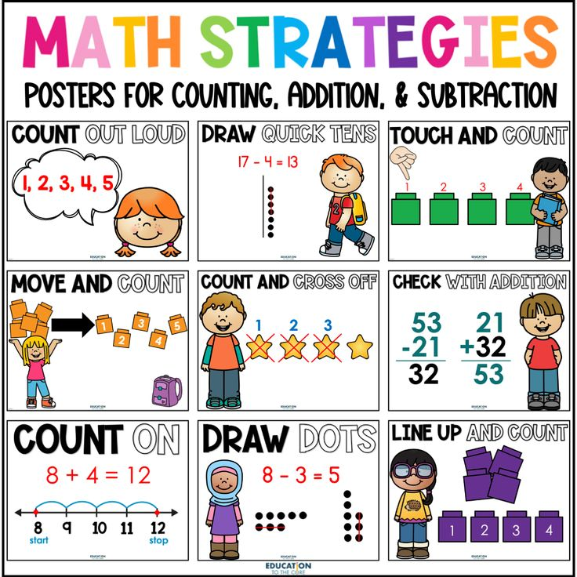

**Expt. No.:2**

**Date:**

**Design to help people to sell their handmade products in metro cities**

**AIM:** To Design an UI that can help people to sell their handmade products in metro cities

**Tools:** Figma, Photoshop

**Steps:**

1. Create a new background layer.
2. Create containers for placing images, icons and logos.
3. Gradient color panel has to be used.
4. Buttons and attractive fonts have been used.
5. Proper navigation should be done to move from one page to another.
6. Login page has to be included.

**Output:**

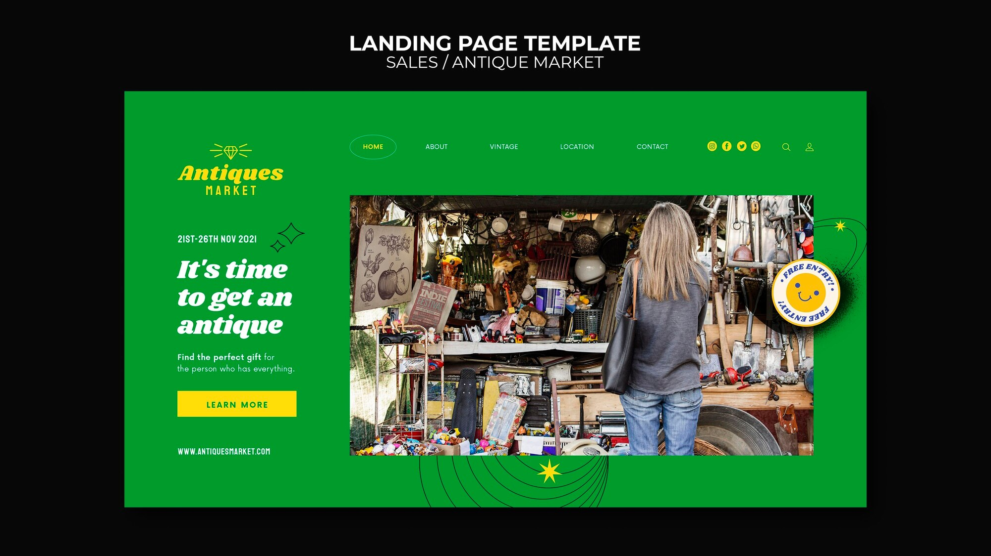

**Result:**

**Hence a UI design is made.**

**Expt. No.:3**

**Date:**

## Design a social media website and chat

**Aim:** To design a user interface for teaching mathematics to the children of 4-5 years age in school in the rural sector.

**Tools:** Figma, Photoshop

**Steps:**

1. Create a new background layer.
2. Create containers for placing images, icons and logos
3. Gradient color panel has to be used
4. Buttons and attractive fonts have been used
5. Proper navigation should be done to move from one page to another
6. Login page has to be included

**Output:**

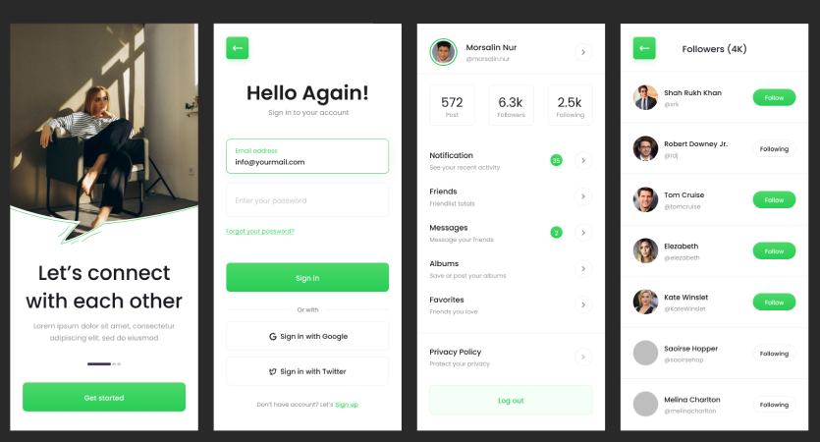

**Result:**

**Hence the UI for social media is done using figma**

**Expt. No.:4**

**Date:**

## Design a publication that support different languages

**Aim:** To design a publication that support different language

**Tools:** Adobe Photoshop

**Steps:**

1. Create a new background layer.
2. Create containers for placing images, icons and logos
3. Gradient color panel has to be used
4. Use different languages to display the content.
5. Use images that support the content.
6. Align white spaces between the contents.

**Output:**

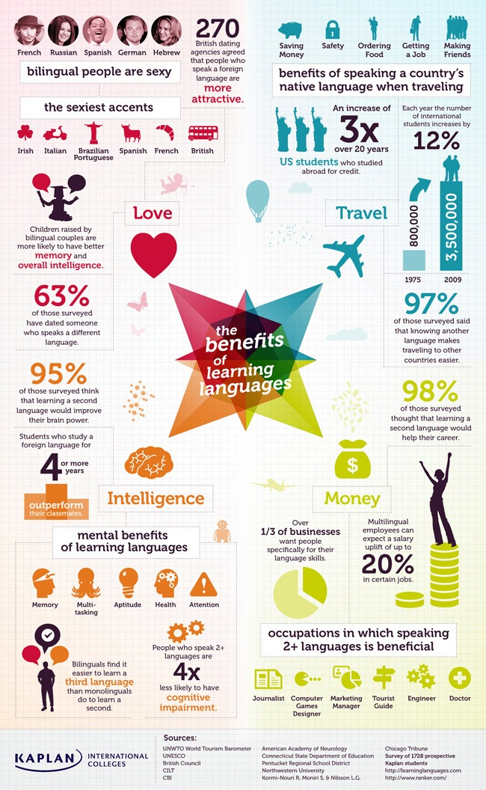

**Result:**

**Expt. No.:5**

**Date:**

**Design a publication that tells comic storiess**

**Aim:** To design a Publication That Tells Comic Stories

**Tools:**  Adobe Photoshop

**Steps:**

1. Create a new background layer.
2. Create containers for placing images, icons and logos
3. Gradient color panel has to be used.
4. Use different languages to display the content.
5. Use images that support the content.
6. Align white spaces between the contents.

**Output:**

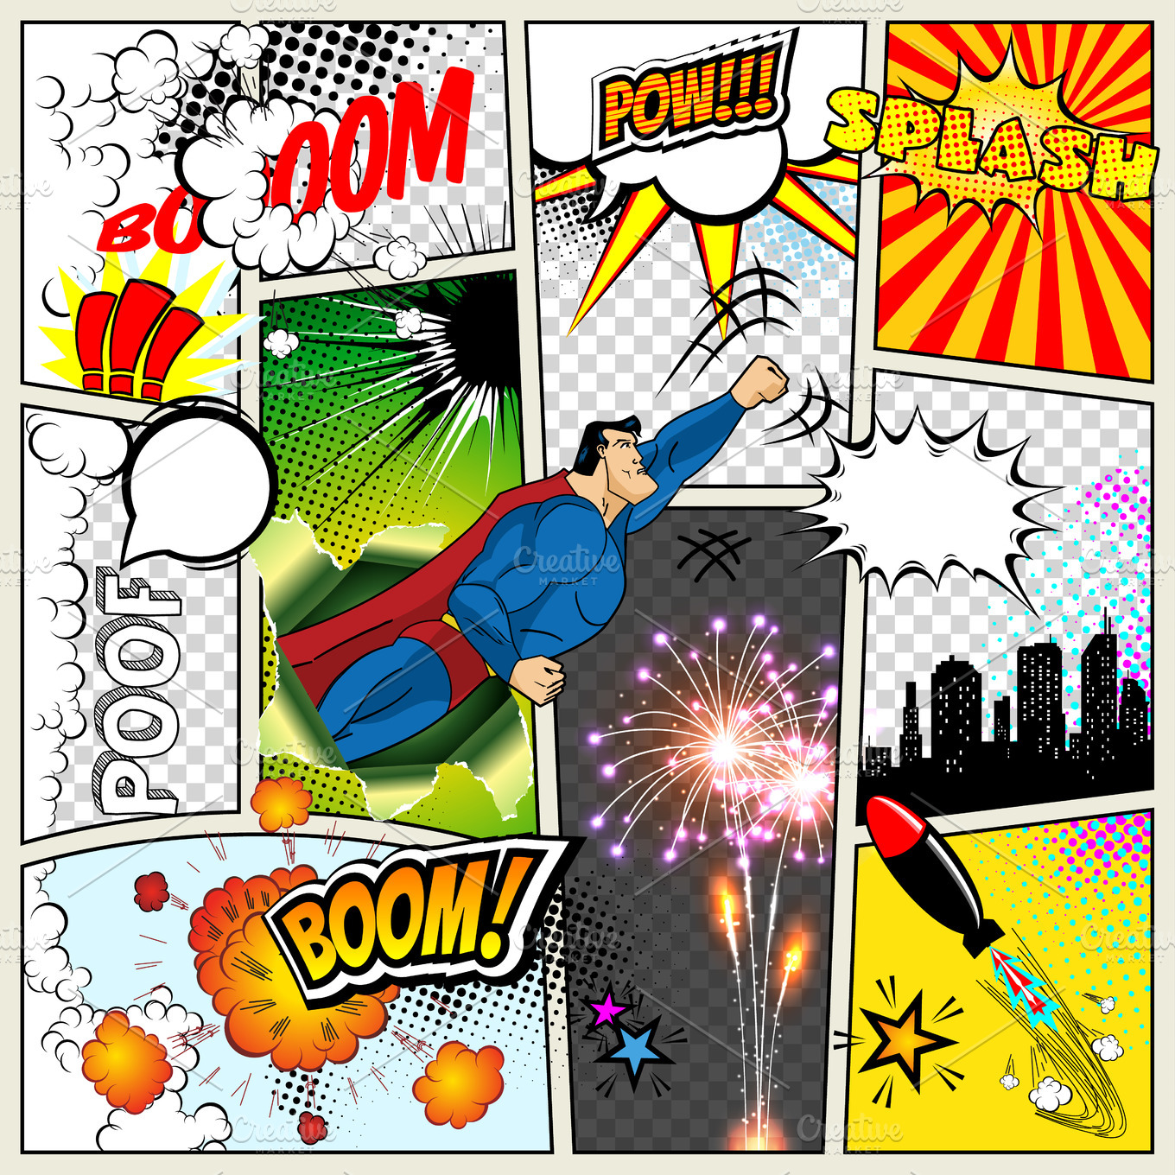

**Result:**

Simple comics using photoshop is made

# Design an advertisement for mobile company

**Aim:** To design an advertisement for mobile company

**Tools:**  Adobe Photoshop, Canva

**Steps:**

1. Create a new background layer.
2. Create containers for placing images, icons and logos
3. Gradient color panel has to be used
4. Images that support the context must be placed.
5. Written context must be emphasized.
6. Appropriate color palette must be used.

**Output:**

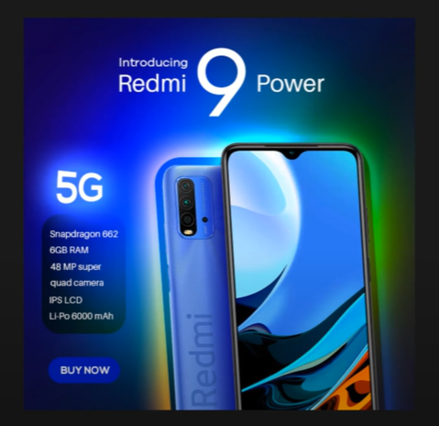

**Result:**

**Hence an advertisement poster for redmi phone is made**

# Design an advertisement for any political party with images

**Aim:** To design an advertisement for any political party with images

**Tools:**  Adobe Photoshop, Canva.

**Steps:**

1. Create a new background layer.
2. Create containers for placing images, icons and logos.
3. Gradient color panel has to be used.
4. Images that support the context must be placed.
5. Written context must be emphasized.
6. Appropriate color palette must be used.

**Output:**

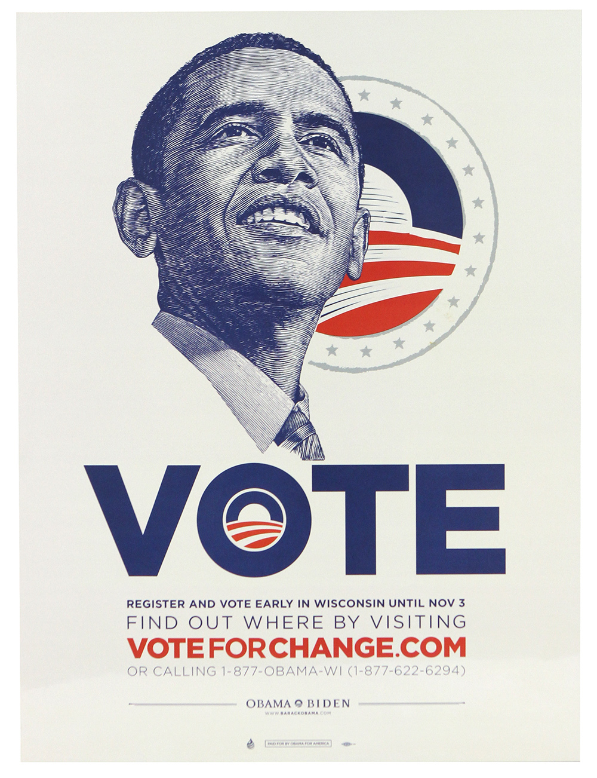

**Result:**

## Design an advertisement for electronic products

**Aim:** To design an advertisement for electronic products

**Tools:**  Adobe Photoshop, Canva

**Steps:**

1. Create a new background layer.
2. Create containers for placing images, icons and logos.
3. Gradient color panel has to be used .
4. Images that support the context must be placed.
5. Written context must be emphasized.
6. Appropriate color palette must be used.

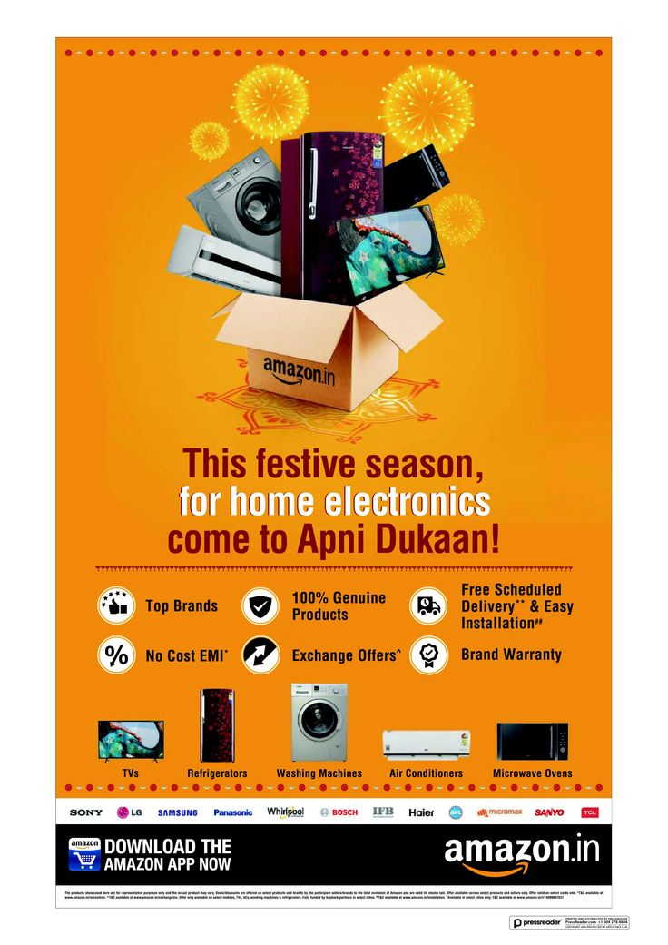

**Output:**

**Result:**

# Design an advertisement for food products

**Aim:** To design an advertisement for food products

**Tools:**  Adobe Photoshop, Canva

**Steps:**

1. Create a new background layer.
2. Create containers for placing images, icons and logos.
3. Gradient color panel has to be used .
4. Images that support the context must be placed.
5. Written context must be emphasized.
6. Appropriate color palette must be used.

**Output:**

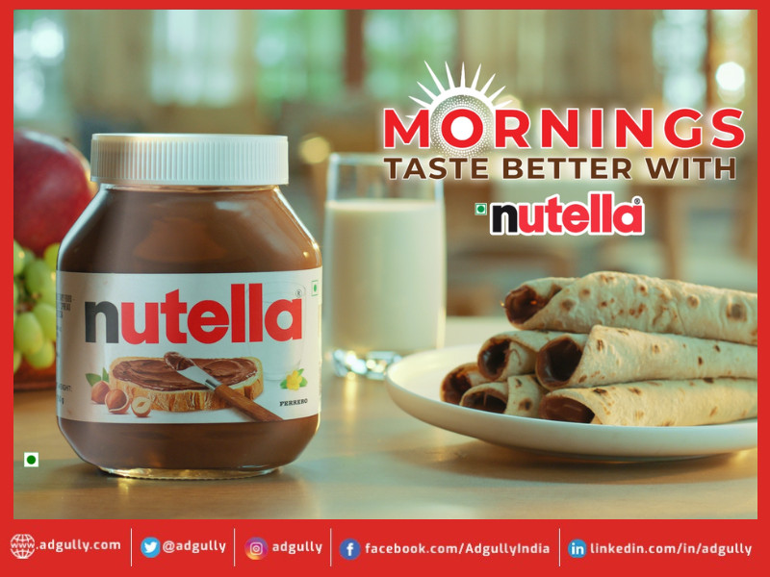

**Result:**

**Hence**

## Design an interactive website for new institution

**Aim:** To design interactive website for new institution

**Tools:** HTML, CSS **Steps:**

1. Create a document of type HTML.
2. Craft a style sheet for better design.
3. Include the link of the stylesheet to the HTML file.
4. Assign a title for each page.
5. Add the required styles and attributes for the HTML tags.
6. Include action tag to navigate from one page to another.

**Output:**

**Code:**

<!DOCTYPE html>

<html lang="en">

<head>

<meta charset="UTF-8">

<meta name="viewport" content="width=device-width, initial-scale=1.0">

<title>Institution Name</title>

<link rel="stylesheet" href="styles.css">

</head>

<body>

<header>

<div class="container">

<h1>Institution Name</h1>

<nav>

<ul>

<li><a href="#about">About Us</a></li>

<li><a href="#courses">Courses</a></li>

<li><a href="#admissions">Admissions</a></li>

<li><a href="#contact">Contact</a></li>

</ul>

</nav>

</div>

</header>

<section id="about">

<div class="container">

<h2>About Us</h2>

<p>Welcome to Institution Name. We provide quality education and foster growth in various fields of learning.</p>

</div>

</section>

<section id="courses">

<div class="container">

<h2>Our Courses</h2>

<ul>

<li>Mathematics</li>

<li>Science</li>

<li>Computer Science</li>

<li>Humanities</li>

</ul>

</div>

</section>

<section id="admissions">

<div class="container">

<h2>Admissions</h2>

<p>Admissions for the academic year are now open. Apply to become a part of our institution today.</p>

<a href="#contact" class="btn">Contact Us</a>

</div>

</section>

<section id="contact">

<div class="container">

<h2>Contact Us</h2>

<p>Email: info@institution.com</p>

<p>Phone: +1 234 567 890</p>

<p>Address: 123 Main Street, Your City</p>

</div>

</section>

<footer>

<div class="container">

<p>&copy; 2024 Institution Name. All rights reserved.</p>

</div>

</footer>

</body>

</html>

**CSS:**

body {

font-family: Arial, sans-serif;

margin: 0;

line-height: 1.6;

color: #333;

}

header {

background: #4CAF50;

color: #fff;

padding: 10px 0;

}

header .container {

display: flex;

justify-content: space-between;

align-items: center;

max-width: 1200px;

margin: auto;

padding: 0 20px;

}

header h1 {

margin: 0;

}

header nav ul {

list-style: none;

padding: 0;

margin: 0;

display: flex;

}

header nav ul li {

margin: 0 10px;

}

header nav ul li a {

color: #fff;

text-decoration: none;

}

section {

padding: 20px 0;

text-align: center;

}

.container {

max-width: 1200px;

margin: auto;

padding: 0 20px;

}

section h2 {

margin-bottom: 10px;

color: #4CAF50;

}

section ul {

list-style: none;

padding: 0;

margin: 0;

}

section ul li {

margin: 5px 0;

}

.btn {

display: inline-block;

background: #4CAF50;

color: #fff;

padding: 10px 20px;

text-decoration: none;

border-radius: 5px;

margin-top: 10px;

}

footer {

background: #333;

color: #fff;

text-align: center;

padding: 10px 0;

}

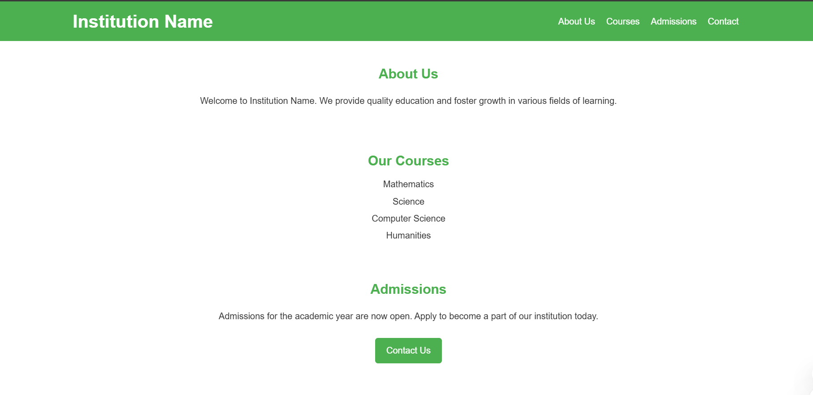

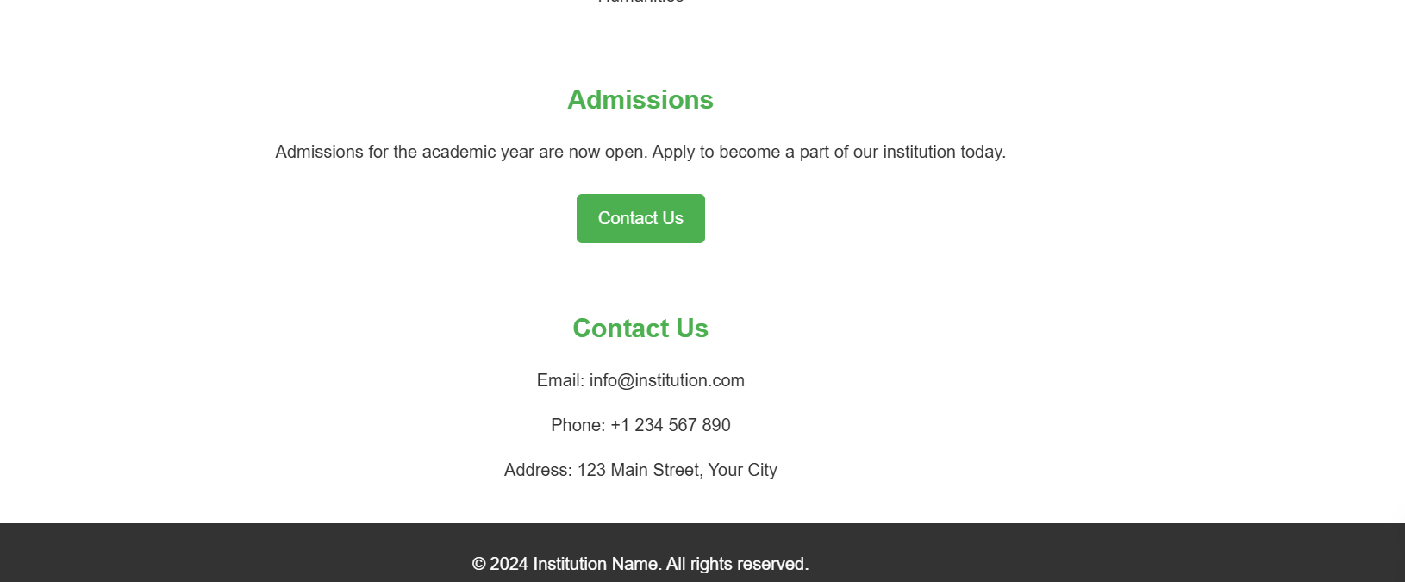

**Result: hence a basic institution landing page using html,css is done**

## 

## 

## Design A Blog That Publish Educational Post

**Aim:** To design a blog that publishes educational post

**Tools:** HTML, CSS

**Steps:**

1. Create a document of type HTML.
2. Craft a style sheet for better design.
3. Include the link of the stylesheet to the HTML file.
4. Assign a title for each page.
5. Add the required styles and attributes for the HTML tags.
6. Include action tag to navigate from one page to another.

**Output:**

**HTML CODE:**

**<!DOCTYPE html>**

**<html lang="en">**

**<head>**

**<meta charset="UTF-8">**

**<meta name="viewport" content="width=device-width, initial-scale=1.0">**

**<title>EduBlog - Learn and Inspire</title>**

**<link rel="stylesheet" href="index.css">**

**</head>**

**<body>**

**<header>**

**<div class="container">**

**<h1>EduBlog</h1>**

**<p>Your daily dose of educational insights and inspiration</p>**

**</div>**

**</header>**

**<nav>**

**<div class="container">**

**<ul>**

**<li><a href="#home">Home</a></li>**

**<li><a href="#categories">Categories</a></li>**

**<li><a href="#popular">Popular</a></li>**

**<li><a href="#contact">Contact</a></li>**

**</ul>**

**</div>**

**</nav>**

**<section id="home" class="hero">**

**<div class="container">**

**<h2>Welcome to EduBlog</h2>**

**<p>Discover educational articles curated just for you.</p>**

**</div>**

**</section>**

**<section id="categories">**

**<div class="container">**

**<h2>Categories</h2>**

**<div class="grid">**

**<div class="card">**

**<h3>Science</h3>**

**<p>Dive into the wonders of the scientific world.</p>**

**</div>**

**<div class="card">**

**<h3>Mathematics</h3>**

**<p>Explore the beauty and logic of numbers.</p>**

**</div>**

**<div class="card">**

**<h3>Technology</h3>**

**<p>Stay updated on the latest tech trends.</p>**

**</div>**

**<div class="card">**

**<h3>History</h3>**

**<p>Learn from the past to understand the present.</p>**

**</div>**

**</div>**

**</div>**

**</section>**

**<section id="popular">**

**<div class="container">**

**<h2>Popular Articles</h2>**

**<div class="article-list">**

**<article>**

**<h3>The Mystery of Black Holes</h3>**

**<p>Explore how black holes shape the universe.</p>**

**</article>**

**<article>**

**<h3>Mathematical Patterns in Nature</h3>**

**<p>Discover the hidden math in everyday life.</p>**

**</article>**

**<article>**

**<h3>The Rise of Artificial Intelligence</h3>**

**<p>Understand the impact of AI on our world.</p>**

**</article>**

**</div>**

**</div>**

**</section>**

**<footer>**

**<div class="container">**

**<p>&copy; 2024 EduBlog. All rights reserved.</p>**

**</div>**

**</footer>**

**</body>**

**</html>**

**CSS CODE:**

**body {**

**font-family: 'Arial', sans-serif;**

**margin: 0;**

**padding: 0;**

**color: #333;**

**line-height: 1.6;**

**}**

**header {**

**background: linear-gradient(to right, #4a90e2, #50e3c2);**

**color: white;**

**text-align: center;**

**padding: 50px 20px;**

**}**

**header h1 {**

**font-size: 3em;**

**margin: 0;**

**}**

**header p {**

**font-size: 1.2em;**

**margin: 10px 0 0;**

**}**

**nav {**

**background: #333;**

**}**

**nav ul {**

**list-style: none;**

**display: flex;**

**justify-content: center;**

**padding: 10px 0;**

**margin: 0;**

**}**

**nav ul li {**

**margin: 0 15px;**

**}**

**nav ul li a {**

**color: white;**

**text-decoration: none;**

**font-size: 1.1em;**

**}**

**.hero {**

**text-align: center;**

**padding: 50px 20px;**

**background: #f4f4f4;**

**}**

**.hero h2 {**

**font-size: 2.5em;**

**margin-bottom: 10px;**

**}**

**section {**

**padding: 40px 20px;**

**text-align: center;**

**}**

**.container {**

**max-width: 1200px;**

**margin: auto;**

**}**

**.grid {**

**display: flex;**

**flex-wrap: wrap;**

**justify-content: center;**

**gap: 20px;**

**margin-top: 20px;**

**}**

**.card {**

**background: white;**

**border: 1px solid #ddd;**

**padding: 20px;**

**border-radius: 8px;**

**box-shadow: 0 2px 4px rgba(0, 0, 0, 0.1);**

**width: 200px;**

**text-align: left;**

**}**

**.card h3 {**

**color: #4a90e2;**

**}**

**.article-list {**

**display: grid;**

**grid-template-columns: repeat(auto-fit, minmax(200px, 1fr));**

**gap: 20px;**

**margin-top: 20px;**

**}**

**article {**

**background: #fff;**

**padding: 15px;**

**border: 1px solid #ddd;**

**border-radius: 8px;**

**box-shadow: 0 2px 4px rgba(0, 0, 0, 0.1);**

**text-align: left;**

**}**

**article h3 {**

**color: #50e3c2;**

**}**

**footer {**

**background: #333;**

**color: white;**

**text-align: center;**

**padding: 20px 0;**

**}**

**OUTPUT:**

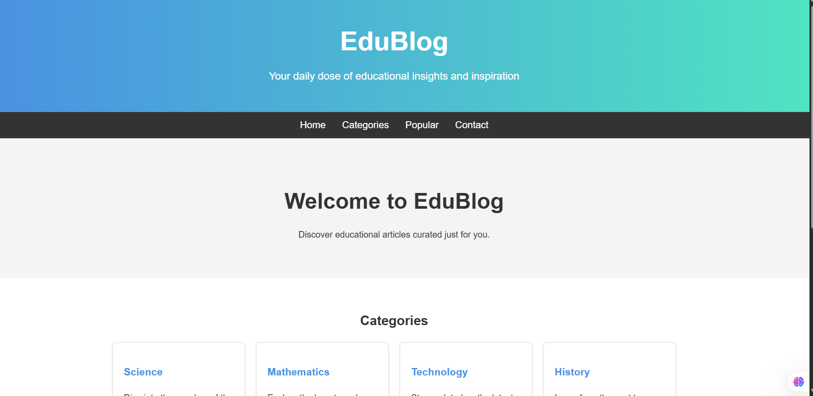

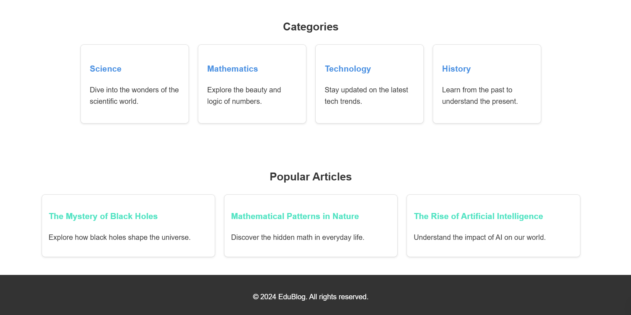

**Result:**

**Hence a basic website of educational blog is done using html and css**

## 

## Design An Interactive Website For Hospital Management System

**Aim:** To design interactive website for hospital management system

**Tools:** HTML, CSS

**Steps:**

1. Create a document of type HTML.
2. Craft a style sheet for better design.
3. Include the link of the stylesheet to the HTML file.
4. Assign a title for each page.
5. Add the required styles and attributes for the HTML tags.
6. Include action tag to navigate from one page to another.

**Output:**

**HTML:**

**<!DOCTYPE html>**

**<html lang="en">**

**<head>**

**<meta charset="UTF-8">**

**<meta name="viewport" content="width=device-width, initial-scale=1.0">**

**<title>Hospital Management System</title>**

**<link rel="stylesheet" href="index.css">**

**</head>**

**<body>**

**<header>**

**<div class="container">**

**<h1>Hospital Management</h1>**

**<p>Efficient and Reliable Care at Your Fingertips</p>**

**</div>**

**</header>**

**<nav>**

**<div class="container">**

**<ul>**

**<li><a href="#home">Home</a></li>**

**<li><a href="#services">Services</a></li>**

**<li><a href="#doctors">Doctors</a></li>**

**<li><a href="#contact">Contact</a></li>**

**</ul>**

**</div>**

**</nav>**

**<section id="home" class="hero">**

**<div class="container">**

**<h2>Welcome to Our Hospital Management System</h2>**

**<p>Streamline your medical processes with ease.</p>**

**</div>**

**</section>**

**<section id="services">**

**<div class="container">**

**<h2>Our Services</h2>**

**<div class="grid">**

**<div class="card">**

**<h3>Patient Management</h3>**

**<p>Track and manage patient records efficiently.</p>**

**</div>**

**<div class="card">**

**<h3>Appointment Scheduling</h3>**

**<p>Book and manage appointments seamlessly.</p>**

**</div>**

**<div class="card">**

**<h3>Medical Records</h3>**

**<p>Secure and reliable medical data storage.</p>**

**</div>**

**<div class="card">**

**<h3>Billing and Payments</h3>**

**<p>Easy and transparent billing solutions.</p>**

**</div>**

**</div>**

**</div>**

**</section>**

**<section id="doctors">**

**<div class="container">**

**<h2>Meet Our Doctors</h2>**

**<div class="grid">**

**<div class="card">**

**<h3>Dr. John Smith</h3>**

**<p>Cardiologist</p>**

**</div>**

**<div class="card">**

**<h3>Dr. Sarah Lee</h3>**

**<p>Neurologist</p>**

**</div>**

**<div class="card">**

**<h3>Dr. Emily Brown</h3>**

**<p>Pediatrician</p>**

**</div>**

**<div class="card">**

**<h3>Dr. Robert Wilson</h3>**

**<p>Orthopedic Surgeon</p>**

**</div>**

**</div>**

**</div>**

**</section>**

**<footer>**

**<div class="container">**

**<p>&copy; 2024 Hospital Management System. All rights reserved.</p>**

**</div>**

**</footer>**

**</body>**

**</html>**

CSS:

body {

    font-family: 'Arial', sans-serif;

    margin: 0;

    padding: 0;

    color: #fff;

    background-color: #121212;

    line-height: 1.6;

}

header {

    background: linear-gradient(to right, #1f1f1f, #333);

    text-align: center;

    padding: 50px 20px;

}

header h1 {

    font-size: 3em;

    margin: 0;

    color: #4caf50;

}

header p {

    font-size: 1.2em;

    margin: 10px 0 0;

    color: #aaa;

}

nav {

    background: #1f1f1f;

    border-bottom: 1px solid #333;

}

nav ul {

    list-style: none;

    display: flex;

    justify-content: center;

    padding: 10px 0;

    margin: 0;

}

nav ul li {

    margin: 0 15px;

}

nav ul li a {

    color: #4caf50;

    text-decoration: none;

    font-size: 1.1em;

}

.hero {

    text-align: center;

    padding: 50px 20px;

    background: #181818;

}

.hero h2 {

    font-size: 2.5em;

    margin-bottom: 10px;

    color: #4caf50;

}

section {

    padding: 40px 20px;

    text-align: center;

}

.container {

    max-width: 1200px;

    margin: auto;

}

.grid {

    display: flex;

    flex-wrap: wrap;

    justify-content: center;

    gap: 20px;

    margin-top: 20px;

}

.card {

    background: #1f1f1f;

    border: 1px solid #333;

    padding: 20px;

    border-radius: 8px;

    box-shadow: 0 2px 4px rgba(0, 0, 0, 0.4);

    width: 200px;

    text-align: left;

}

.card h3 {

    color: #4caf50;

    margin-bottom: 5px;

}

.card p {

    color: #aaa;

}

footer {

    background: #1f1f1f;

    text-align: center;

    padding: 20px 0;

    border-top: 1px solid #333;

    color: #aaa;

}

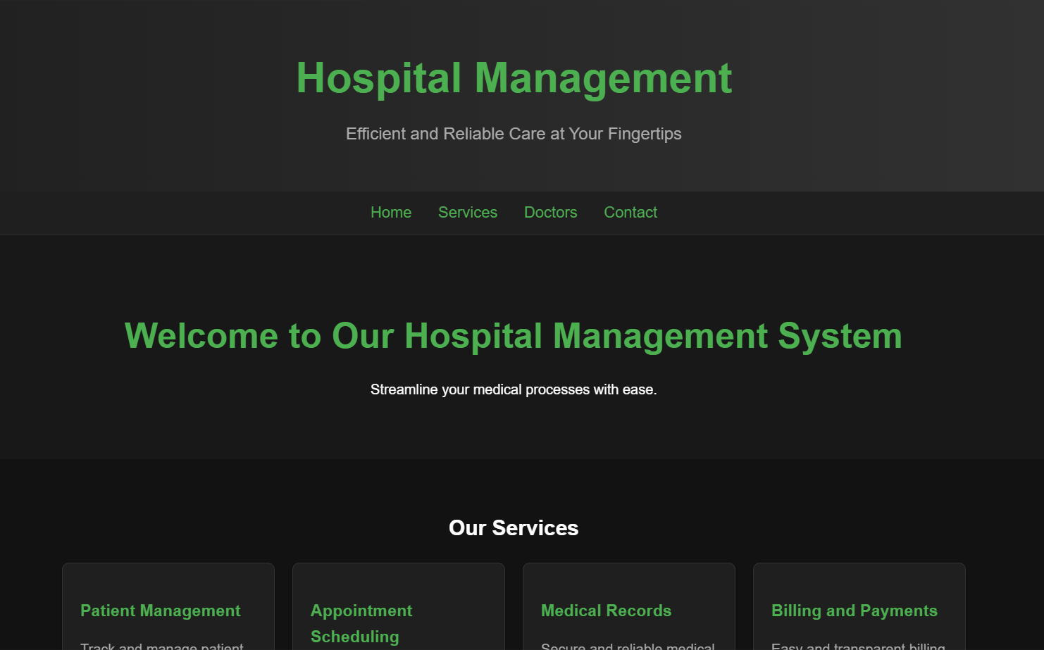

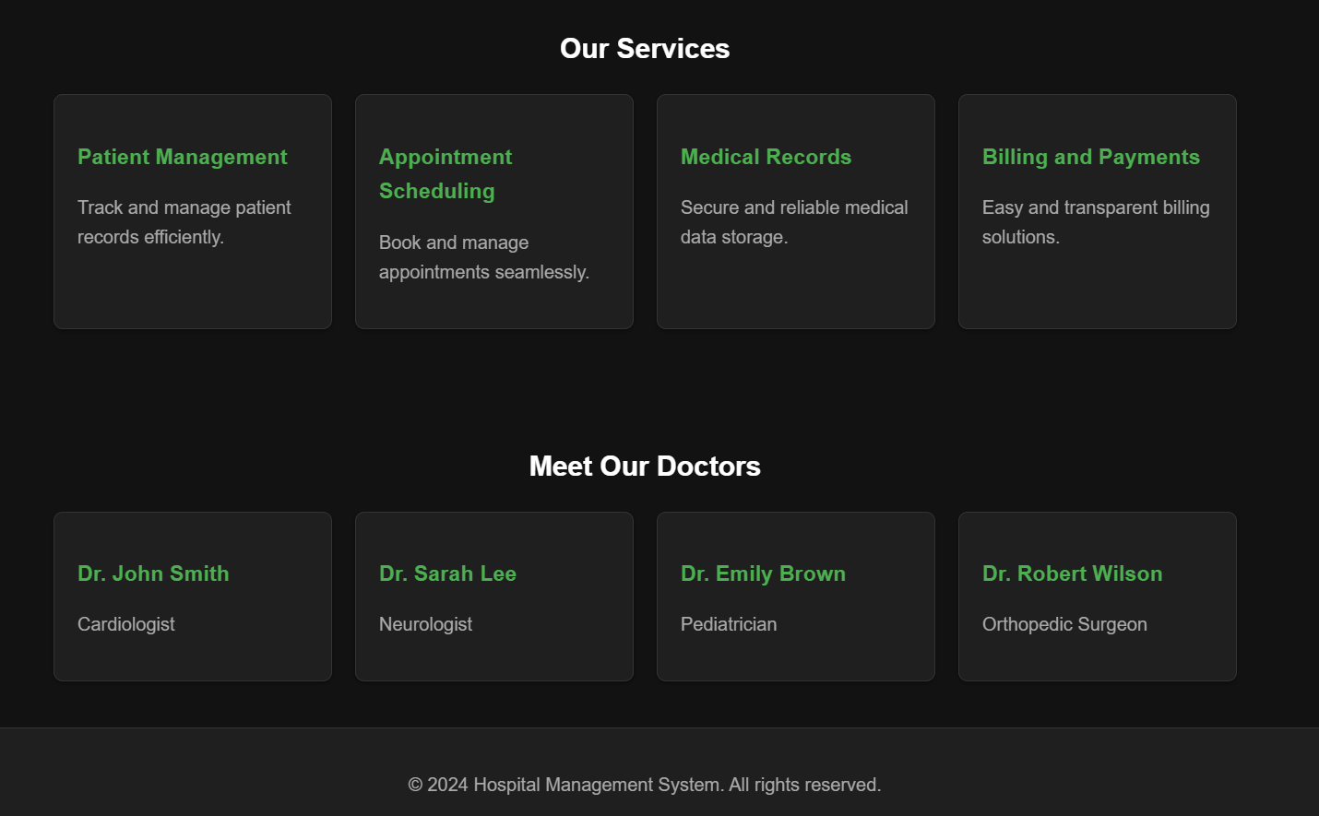

**Result:**

Hence an hospital management app is designed using html and css

**Expt. No.:13**

**Date:**

## Design An Interactive Website For Food Selling App

**Aim:** To design a interactive website for food selling app

**Tools:** HTML, CSS

**Steps:**

1. Create a document of type HTML.
2. Craft a style sheet for better design.
3. Include the link of the stylesheet to the HTML file.
4. Assign a title for each page.
5. Add the required styles and attributes for the HTML tags.
6. Include action tag to navigate from one page to another.

**Output:**

**<!DOCTYPE html>**

**<html lang="en">**

**<head>**

**<meta charset="UTF-8">**

**<meta name="viewport" content="width=device-width, initial-scale=1.0">**

**<title>Food Selling App</title>**

**<link rel="stylesheet" href="styles.css">**

**</head>**

**<body>**

**<header>**

**<div class="container">**

**<h1>Foodies Paradise</h1>**

**<p>Delicious Meals at Your Fingertips</p>**

**</div>**

**</header>**

**<nav>**

**<div class="container">**

**<ul>**

**<li><a href="#home">Home</a></li>**

**<li><a href="#menu">Menu</a></li>**

**<li><a href="#about">About Us</a></li>**

**<li><a href="#contact">Contact</a></li>**

**</ul>**

**</div>**

**</nav>**

**<section id="home" class="hero">**

**<div class="container">**

**<h2>Welcome to Foodies Paradise</h2>**

**<p>Explore a wide variety of dishes crafted just for you.</p>**

**<a href="#menu" class="button">Order Now</a>**

**</div>**

**</section>**

**<section id="menu">**

**<div class="container">**

**<h2>Our Menu</h2>**

**<div class="grid">**

**<div class="card">**

**<h3>Spicy Burger</h3>**

**<p>Hot, juicy, and packed with flavors.</p>**

**</div>**

**<div class="card">**

**<h3>Pasta Delight</h3>**

**<p>Creamy and perfectly seasoned.</p>**

**</div>**

**<div class="card">**

**<h3>Grilled Sandwich</h3>**

**<p>Golden, crispy, and loaded with fillings.</p>**

**</div>**

**<div class="card">**

**<h3>Chocolate Lava Cake</h3>**

**<p>A heavenly treat for your sweet tooth.</p>**

**</div>**

**</div>**

**</div>**

**</section>**

**<section id="about">**

**<div class="container">**

**<h2>About Us</h2>**

**<p>At Foodies Paradise, we are dedicated to serving fresh, delicious meals made with love. Whether you're craving a quick snack or a full meal, we've got you covered.</p>**

**</div>**

**</section>**

**<footer>**

**<div class="container">**

**<p>&copy; 2024 Foodies Paradise. All rights reserved.</p>**

**</div>**

**</footer>**

**</body>**

**</html>**

**CSS:**

body {

font-family: 'Arial', sans-serif;

margin: 0;

padding: 0;

color: #fff;

background-color: #121212;

line-height: 1.6;

}

header {

background: linear-gradient(to right, #1f1f1f, #2b2b2b);

text-align: center;

padding: 50px 20px;

}

header h1 {

font-size: 3em;

margin: 0;

color: #ff6347; /* Reddish highlight */

}

header p {

font-size: 1.2em;

margin: 10px 0 0;

color: #ccc;

}

nav {

background: #1f1f1f;

border-bottom: 1px solid #333;

}

nav ul {

list-style: none;

display: flex;

justify-content: center;

padding: 10px 0;

margin: 0;

}

nav ul li {

margin: 0 15px;

}

nav ul li a {

color: #ff6347;

text-decoration: none;

font-size: 1.1em;

}

.hero {

text-align: center;

padding: 50px 20px;

background: #181818;

}

.hero h2 {

font-size: 2.5em;

margin-bottom: 10px;

color: #ff6347;

}

.hero .button {

display: inline-block;

margin-top: 20px;

padding: 10px 20px;

color: #fff;

background: #ff6347;

text-decoration: none;

font-size: 1.1em;

border-radius: 5px;

transition: background 0.3s ease;

}

.hero .button:hover {

background: #e5533d;

}

section {

padding: 40px 20px;

text-align: center;

}

.container {

max-width: 1200px;

margin: auto;

}

.grid {

display: flex;

flex-wrap: wrap;

justify-content: center;

gap: 20px;

margin-top: 20px;

}

.card {

background: #1f1f1f;

border: 1px solid #333;

padding: 20px;

border-radius: 8px;

box-shadow: 0 2px 4px rgba(0, 0, 0, 0.4);

width: 200px;

text-align: left;

}

.card h3 {

color: #ff6347;

margin-bottom: 5px;

}

.card p {

color: #aaa;

}

footer {

background: #1f1f1f;

text-align: center;

padding: 20px 0;

border-top: 1px solid #333;

color: #ccc;

}

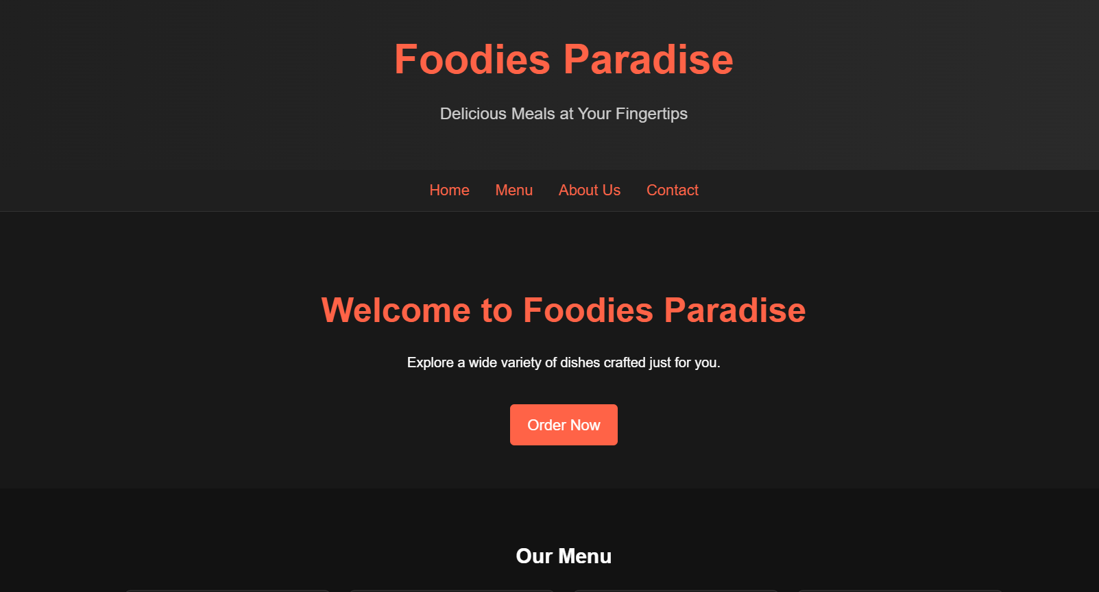

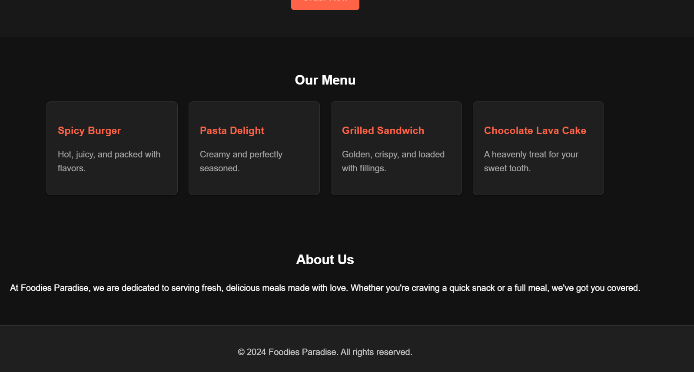

**Result**

**Hence food app is made using HTML and CSS.**